

Technical System Design
For
Space Range and Display
Sales Aggregation

Distribution
Andrew Barker | Hilary Waterhouse | Jim Jeffery
Kavita Suri | Mary Welch | Eva Hotmarova
For Information

Author: Sudha Vaidyanathan
Date: 23-May-2007
Version: 0.6.1

Amendment History

S.No. | Modified by | Modified On | Modification
1 | Sudha Vaidyanathan | 29-03-2007 | 0.1 Draft Version
2 | Sudha Vaidyanathan | 19-04-2007 | 0.2 Updated the data model and file conventions
3 | Sudha Vaidyanathan | 23-04-2007 | 0.3 Updated with the review comments from Integration Layer team
4 | Sudha Vaidyanathan | 25-04-2007 | 0.4 Updated with the review comments from Andrew Barker
5 | Sudha Vaidyanathan | 18-05-2007 | 0.5 Updated with the Change request for sign off
6 | Sudha Vaidyanathan | 23-05-2007 | 0.6 Sign off version updated with Jim and Andy’s comments

Related Documents

Ref. | Document Title | Type | Author | Date Issued
1 | Sales Aggregation BRD V0.5 | Doc | Sudha Vaidyanathan | 19-Mar-2007
2 | BSD for Sales Aggregation V0.6 | Doc | Sudha Vaidyanathan | 17-May-2007

Table of Contents
1. Introduction 4
1.1 Background 4
1.2 Scope 4
1.3 Assumptions 6
1.4 Outstanding Risks/Issues/Questions 7
1.5 In Progress/Pending 7
2. Architectural Overview 8
2.1 Contextual Architecture 8
2.2 Logical Architecture 11
2.3 Physical Architecture 12
2.4 Deployment Architecture 15
3. Detailed System Design 17
3.1 Overview 17
3.2 Local Data Preparation Component 17
3.2.1 Design Specifications 17
3.2.2 Component Architecture 17
3.2.3 Class Diagram and Method Description 17
3.3 Local Data Load Component 19
3.3.1 Design Specifications 19
3.3.2 Component Architecture 19
3.3.3 Class Diagram and Method Description 22
3.4 Data Processing Engine 24
3.4.1 Design Specifications 24
3.4.2 Component Architecture 24
3.4.3 Class Diagram and Method Description 27
3.5 Response Component 28
3.5.1 Design Specifications 28
3.5.2 Component Architecture 28
3.5.3 Class Diagram and Method Description 29
3.6 House keeping Component 32
3.6.1 Design Specifications 32
3.6.2 Approach 32
4. Exception Handling and Logging 33
4.1.1 Logging Mechanism 33
5. File Layout 34
6. Database Design 36
Tables 39
6.1.1 tbl_Staging_In_Agg_Product_Params 39
6.1.2 tbl_Staging_In_Agg_Store_Params 40
6.1.3 tbl_Staging_In_Agg_Period_Params 41
6.1.4 tbl_Staging_In_Sales_Detail 42
6.1.5 tbl_Staging_In_Planogram_Params 43
6.1.6 tbl_Config_Param 43
6.1.7 tbl_Temp_Agg_PerformanceData 44
6.1.8 tbl_Sales_Data_Planogram 45
6.1.9 tbl_Sales_Planogram_History 46
6.1.10 tbl_Agg_Performance_Request 47
6.1.11 tbl_Planogram_Params 48
6.1.12 tbl_Sales_Data_History 48
6.1.13 tbl_Staging_Out_Product 49
6.1.14 tbl_Staging_Out_Product_Planogram 50
6.1.15 tbl_Staging_Out_Planogram_Store 51
6.1.16 tbl_Staging_Out_Planogram 52
6.1.17 tbl_Staging_Out_Agg_PerformanceData 52

Introduction

The Space, Range and Display (SRD) stream within Group IT has identified a need to summarise sales data to assist with Ranging and Display. In the Tesco Operating Model (TOM), there is a need to source this sales data, and present it to the SRD systems for summarisation across a cluster of stores (or all stores), a (display) group of products, and one or more weeks, up to 2 years of history.

This aggregated sales history data will be available to Range system and IKB to generate store ranges and Planogram.

The System Requirements for SRD Sales aggregation for US and Turkey stores have been completed by Business team. Following documents provide details on overall requirements and business design for those requirements.

S.No. | Document Title | Author | Date Issued
1 | BSD for Sales Aggregation V0.6 | Sudha Vaidyanathan | 17-May-2007
2 | Sales Aggregation BRD V0.5 | Sudha Vaidyanathan | 19-Mar-2007

Background

This document describes the Technical Systems Design required to meet the Business Systems Design as documented in the “BSD for Sales Aggregation V0.6” document authored by Sudha Vaidyanathan.

The systems design details within this document will relate only to requirements that are to be delivered within Priority 1 delivery for Space Range and Display.
The completion and Sign off of this document will pave the way for the build phase of the system.

Scope

The section below gives a snapshot of In Scope and Out of Scope requirements from the Business Requirements Document which will be fulfilled by the development of the Sales aggregation

In Scope

Requirement Reference | Requirement description
001 | The Sales Aggregation Engine must provide an interface to enable Aggregated Sales History Data to be requested for a set of provided Item Numbers over a provided aggregation period and for a provided set of Stores associated with a Range Event.
002 | The Sales aggregation engine must create a response data set of sales performance data.  - The response data set will be sent to RPAS on a daily basis.  - The aggregated performance data in the form of a flat file will be produced every day.
003 | The Sales Aggregation Engine must generate rolling 52 weeks historical sales and one week of actual sales data for IKB.  - The actual sales data will be calculated for the current week and the historic sales data would be calculated for a rolling 52 week period. These data would be aggregated for four aggregation levels namely Product, Product/Planogram, Planogram and Planogram/store.  - The Replenishment interface will be generating a flat file on a daily basis containing the changes in the Product – Planogram – Store mapping details. This file would be used by the SAE to update the Base mapping details stored in the Sales History database with the live event details. The SAE then aggregates the sales data for each of the Product – Planogram – Store combination based on the aggregation levels described above.  - 4 output files would be generated – one each for the aggregation based on Product, Product/Planogram, Planogram, Planogram/Store.
004 | The source un-aggregated Sales data must be populated into the Sales History database of the Sales aggregation engine on a daily basis. This would then be used for the calculation of aggregated sales data for the RPAS and IKB.
005 | The sales aggregation engine must perform weekly house keeping activities on the Sales History database.  - Automatically clean the Sales history database for data which is beyond 2 years.

Out of Scope

Requirement Reference | Requirement description
001 | The production of the CRDB request files is out of scope of the Sales aggregation engine. The input request files needs to be placed by the integration layer in a specified input folder accessible to the Sales aggregation engine.
002 | The Sales aggregation engine will place the aggregated response file for RPAS daily in a specific output folder, which is accessible to the Integration layer. The actual transport to the RPAS system is out of scope of the Sales aggregation engine.
003 | The Sales data request from IKB is handled using replenishment interface. The aggregated response file will be placed in a specified output folder, which is accessible to the Integration layer. The generation of the IKB input file and the transportation of the IKB response set is out of scope of the Sales aggregation engine.
004 | The extraction of the Sales data from the ORMS database in the specified format on a daily basis is out of scope of the Sales aggregation engine. The extract file needs to be placed in a specific input folder accessible to the Sales aggregation engine.
005 | The house keeping job will be done automatically by the engine to satisfy the given requirements. Sales data will be maintained in the sales history database for a period of 2 years only. Any other manual house keeping jobs to satisfy other requirements (for e.g. database size has crossed maximum limit etc) is out of the scope of this engine. The automatic cleaning of the discontinuous products from the Sales history database is out of scope at the moment.

Change Request

The following table details the change in requirements that are in scope of Sales Aggregation.

Requirement Reference | Requirement description
002 | The Sales data response into RPAS must be modified to include three more fields.

Assumptions

Following assumptions have been made while writing the Technical design of the Sales aggregation solution for SRD:

- The input from the external interfaces viz., RPAS, ORMS and IKB databases, required for the Sales aggregation application will be available in specific input folders (exact location TBD during development phase) accessible by the engine, at the specified timings of the day. The output will also be placed in specific output folders in the same manner. There will be only file per interface per type expected in the format as described in the below sections.
- The input from the external interfaces should be in the form of text files (.txt extension). The files should contain header, body and footer. The body rows should be fixed length and pertaining to the layout mentioned in the corresponding interface documents.
- The output response data set will also be presented in the form of fixed length flat files containing header, body and footer. The body row length will be fixed and the format of the file would be detailed in a separate section below.
- SSIS packages will be created to implement the data load, maintenance clean up and file writing functions.
- A specific SQL Server user would be created on the SQL server and having the following access permissions.
Read/Write from locations where input/output files are to be placed.
Import/Export SSIS packages on the server.
Execute SSIS packages from the server.
Read/Write access to the Sales aggregation schema and all tables under it.
Execute stored procedures
- It is assumed that the files received from the external systems would be in the defined format. If for some reasons, the file is not as per required format, then it may fail loading. For this scenario and any other scenario where the engine is unable to proceed due to wrong data format, incomplete requisites etc, then it would automatically log an appropriate error message and stop the aggregation engine.
- Master copy of IKB request would be with IKB database and should be available on corruption or loss of data.
- The IKB team would provide the SAE with the details of the entire existing Product – Planogram – Store mapping details for each country where the SAE is planned to be installed in the form of Replenishment Interface file. This can be done either as a pre setup one time migration task or the details can be included in the first day file that would be sent to the SAE.
- There would be one Replenishment Interface file each day from IKB containing the changed product-Planogram-store information for a Planogram-store combination. SAE to process the file and load only details of those live events whose live date is less than or equal to the week end date. SAE to replace the entire details in its base table, for the particular Planogram-store combination coming in the input file.

Outstanding Risks/Issues/Questions

Risk & Impact | Probability | Mitigating steps
The necessary test data setup to test the working of the aggregation engine | High | Follow up is being done to get consistent data from all the systems involved. In case of non availability of data from the systems, then data needs to be prepared manually. No tool or means has been decided till now to prepare data for all the systems.
Specific Non functional requirements have not been requested | High | Only the non functional requirements mentioned in the different sections of this document have been covered and any additional such requirement coming at a later stage should be dealt separately.
The behaviour of the engine in case of any errors and the error propagation means in such scenarios are not clearly mentioned. | High | Error messages will be logged into the event viewer and the log files and the engine will stop its processing at that particular stage.
ORMS feed format to Sales Aggregation Engine is not clear. | High | The integration team needs to send Sales Aggregation specific data from ORMS as specified in BSD V0.5
SAE would need an ORMS extract containing the Sales history details for the country till the Go Live time. This can be either done as a pre setup one time migration task or the details can be included in the first day dump that would be sent to the SAE. | High | The mode in which SAE would receive and upload this data is still under question and needs to be discussed with the concerned stake holders.

In Progress/Pending

- Sample data from ORMS and IKB-Replenishment interfaces have been requested to study the nature of data possible for each of the fields.

Architectural Overview

Contextual Architecture

This section captures the high level context from the Business Requirements in form of a data flow diagram.

Following functions are required to be developed as part of this solution for supporting the business requirements

  - Load ORMS Sales Data Extract
  - Load RPAS input and Create Requests
  - Aggregation of Sales data and production of Daily Response file for RPAS
  - Load IKB input data
  - Aggregation of Sales data and production of Weekly Response files for IKB
  - House keeping activities

Load ORMS Sales data extract

Load ORMS Sales data extract functionality requires following functions to be done on the system.
- At a specific time every day morning, Check for the availability of the ORMS input data extract file in the specified Input file location. The polling interval, location are configurable values.
- Once available, call a routine which would format the input file by stripping the footer record from it. The formatting of all the files is handled by a DOTNET routine. The header information is skipped in the SSIS package.
- Pass the input file name and folder path and Invoke the SSIS package, to load the data into tbl_Staging_in_Sales_Detail table.
- Once the data is loaded, populate an entry into the table tbl_Config_Param and check for the completion of other services as well. Since the response to RPAS depends on data load into the table’s tbl_Staging_In_Agg_Store_Params, tbl_Staging_In_Agg_Period_Params, tbl_Staging_In_Agg_Product_Params and tbl_Staging_In_Sales_Detail, an entry will be made into the tbl_Config_Param when even the particular service associated with each table loading is successful.

Diagram below depicts the data flow in this functionality. All the above mentioned processes are numbered in the data flow according to the sequence in which they are executed.

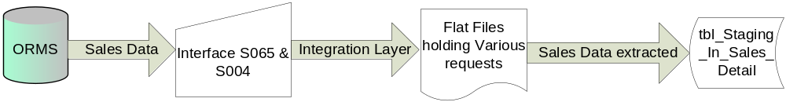

Load RPAS input and Create Requests

Load RPAS input and Create Requests functionality require following functions to be done on the system.
- At a specific time every day morning, Check for the availability of the 3 input files from RPAS in the specified Input file location. The polling interval, location are configurable values.
- Once available, call the routine which would format the input files by stripping the footer records from them. The formatting of all the files is handled by a DOTNET routine. The header information is skipped in the SSIS package.
- Pass the input file names and folder path and invoke the respective SSIS packages then to load the data from each of the input files into a corresponding temp table.
- Once the data is loaded, populate an entry into the status table and check for the completion of other services as well.
- If the service completion status is true, invoke a stored procedure named usp_AggPerformanceDataRequestDataPopulate which will gather following specific fields from each of the tables and form the requests and populate the RPAS Request table :

  - Aggregation period details from tbl_Staging_In_Agg_PeriodParms.
  - Store Id and Store cluster id from tbl_Staging_In_Store_Parms.
  - Display group and product id of tbl_Staging_In_Agg_ProductParms

- Delete the data from all the staging in tables from CRDB.

Diagram below depicts the data flow in this functionality. All the above mentioned processes are given according to the sequence in which they are executed.

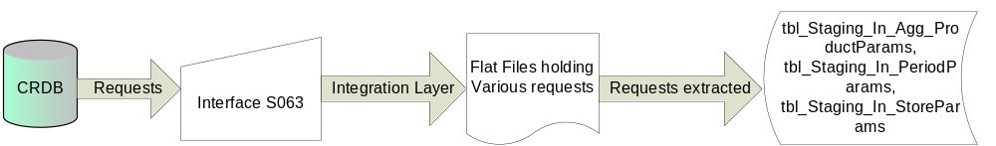

Aggregation of Sales data and production of Daily Response file for RPAS

Aggregation of Sales data and production of Daily Response file for RPAS functionality requires following functions to be done on the system.
- Once the RPAS requests table is loaded, Invoke a stored procedure named usp_ProcessAggPerformanceDataResponse which would aggregate the sales data from tbl_Sales_Data_History and inserts into table tbl_Staging_Out_Agg_PerformanceData based on the requests, calculate a few fields and populate the final table for the RPAS response data set.
- Invoke a SSIS package then, which will read the data from the RPAS response table and writes into a flat file.
- The formatting of the data as requested in the output response file for the fields would be done by the package.
- A routine would then add the standard header and footer to the file and place it in the specified output file location.
- After the file generation is complete, the data in the RPAS requests table and the RPAS response table should be purged.
- The input files and the temp files from the working folder should be cleaned up.

Diagram below depicts the data flow in this functionality. All the above mentioned processes are given according to the sequence in which they are executed.

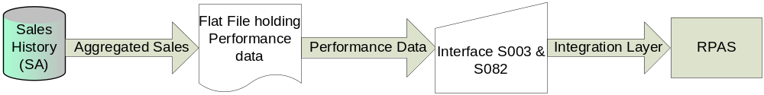

Load IKB input data

Load IKB input data functionality requires following functions to be done on the system.
- At a specific time each morning, Check for the availability of the IKB input file in the specified location.
- Once available, call a routine which would format the input file by stripping the footer record from it. The stripping of header record would be handled by SSIS package itself (No validation check would be made for header and footer record as we are ignoring them).
- Invoke the SSIS package then, to load the data into a table tbl_Staging_In_Planogram_Params table.
- Call a stored procedure which would then cleanup the data from the tbl_Planogram_Parms table for the Planogram-store combinations available in the temp table. After the cleanup, load the information from the temp table into the base table. Purge the data from the temp table.

Diagram below depicts the data flow in this functionality. All the above mentioned processes are given in the data flow according to the sequence in which they are executed.

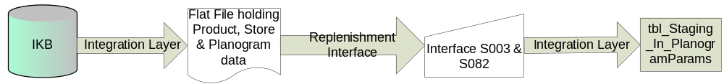

Aggregation of Sales data and production of Weekly Response files for IKB

Aggregation of Sales data and production of Weekly Response files for IKB functionality requires following functions to be done on the system.
- Once every week, at a specified time, invoke a stored procedure named usp_PlanogramResponseMain which would then aggregate the actual and historic sales data for the live Planogram data available in the base mapping table in sales History database. This stored procedure then calculate a few fields and populate the final tables for the IKB response data set – one table each for the 4 response files to IKB. This would be done in following way:

  - Call stored procedure usp_ProcessPlanogramFinalData which inserts data into table tbl_Sales_Planogram_History from table’s tbl_Sales_Data_Planogram A and table tbl_Planogram_Params on fields Product id and store id.
  - Call stored procedure usp_LoadPlanogramFinalData which finally upload data from table tbl_Sales_Planogram_History into four staging out tables named tbl_Staging_Out_Product,tbl_Staging_Out_Planogram, tbl_Staging_Out_Product_Planogram, tbl_Staging_Out_Planogram_Store.
  - Delete data from table tbl_Sales_Planogram_History.

- The aggregated sales data would be extracted from each of these 4 tables into 4 flat files, each file corresponding to an aggregation level.
- Before loading data into the final IKB output tables, purge the data in those tables for any of the previous weeks.
- The input files and the temp files from the working folder needs to be cleaned up.

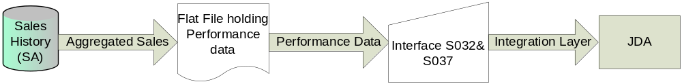

House keeping activities

House keeping activities functionality requires following functions to be done on the system.
- A stored procedure named usp_SalesHistoryCleanUp will be scheduled to run at a specified time each day. It will check for the data in the sales history database (tbl_Sales_Data_Planogram, tbl_Sales_Data_History, tbl_Staging_In_Sales_Detail) which are more than 2 years old (ie week number is less than last 53th tesco week) and purge them.

Following are the non-functional business requirements being considered during the design

  - The daily response files to RPAS should be made available every morning.
  - Design of the sales history table to hold 2 years of data and aiding the data processing with little issues

Logical Architecture

Logically, the system is designed in multiple components. The Architecture that has been followed to meet the above mentioned requirements is given below:

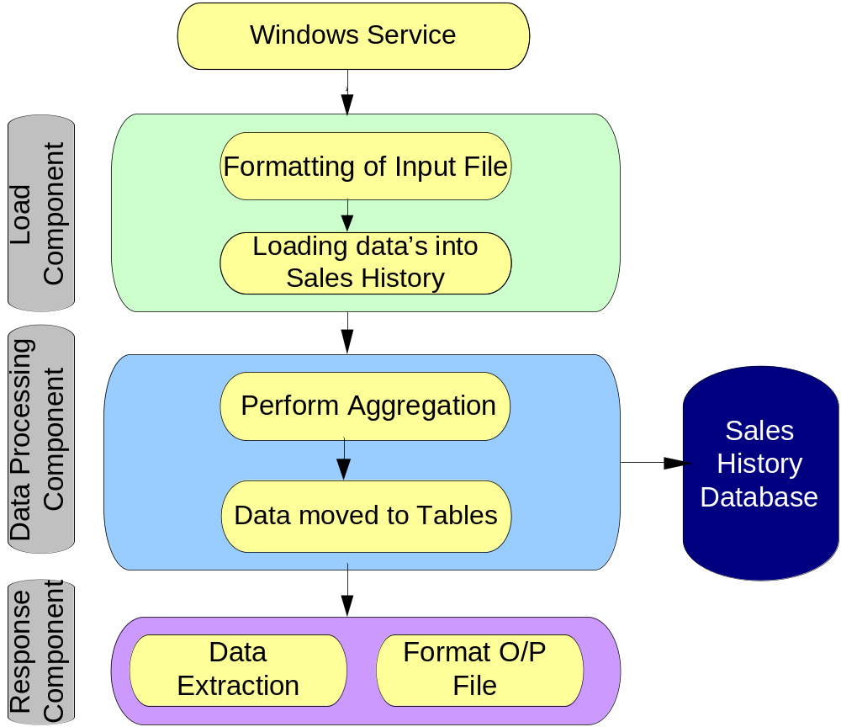

- Load Component: This component is responsible for loading the data from the various input interfaces into the Sales history database. This component is triggered from a windows service and involves the custom formatting of the input files before they are loaded. This custom formatting is the removal of header and footer from the file.

- Data Processing Component: This component performs the necessary aggregation and transformation by applying the business logic involved and moves the data into appropriate data tables.

- Response Component: This component is responsible for writing the response data set in the form of flat files and making it available to the requesting systems.

Physical Architecture

The pictorial representation of Physical architecture is given below on the next page

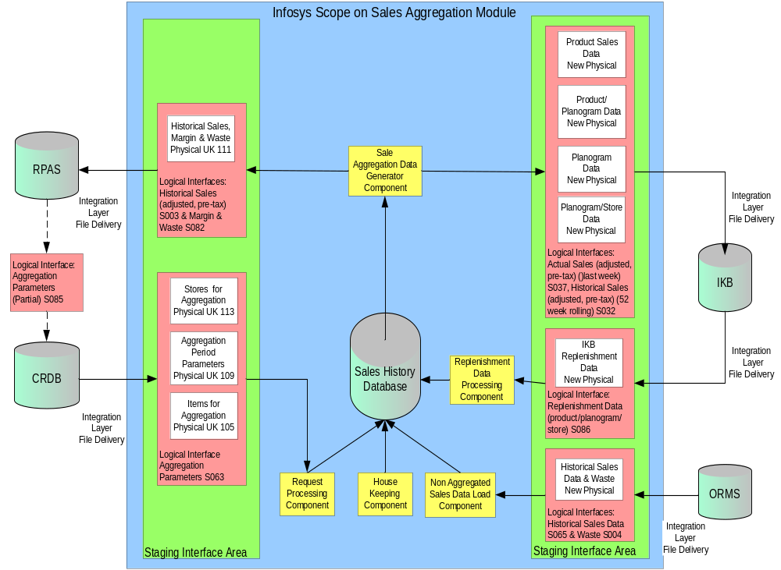

- Data Preparation Component: The Local Data Preparation component is a part of the Non Aggregated Sales Data Load component, Replenishment Data Processing component and Request Processing component. This is a .Net assembly that contains local custom functions to format the input files, like removing the footer row and renaming the file, if necessary. The header row will be ignored by the SSIS package.
The runtime configuration settings for the Local Data Preparation component are defined in a Configuration File placed in a sub folder under the common working folder.
It corresponds to a section in the Load Layer in the Logical Architecture.

- Request processing Component: This component is a part of the Non Aggregated Sales Data Load component, Replishment Data Processing component and Request Processing component. It handles the loading of the formatted input data into the Sales history database with the help of custom SSIS packages. This ETL facility from SQL Server eases the job of data load into the database from varied sources. It corresponds to a section of the Load Layer in the Logical Architecture.

- Data Processing Component: Data Processing engine invokes separate Data Processing Stored procedures which takes care of the business logic involved and calculates the aggregated Sales data information for RPAS and the Actual Sales and Historical Sales information for IKB, on a daily and weekly basis respectively. The data is formatted according to the response file formats defined and stored in specific response tables.
It corresponds to the Data Processing Layer in the Logical Architecture.

- Sales Aggregation Data Generator Component: This component consists of a series of SSIS packages which read the formatted data from the response tables and write them into Response Flat files. It then calls a .NET routine, which adds the standard header and footer information to each of the files. It corresponds to the Response Layer in the Logical Architecture

- House Keeping Component: This component will do the regular clean up of the Sales History database for sales data which are older than 2 years. This is achieved through the help of a scheduled store procedure that runs once each day at a specified time.

- Logging Component: This is sub component of all the above mentioned components. This logs the application messages for the engine run. It provides details like the status of each step and some standard log messages in case of any errors. One log file would be produced for each of the service. These log file will be written in a sub folder under the Common working folder used by the Sales aggregation engine. There will also be a separate standard SSIS package log file which will also be produced in the same folder. The exception messages will be logged into the application event viewer.

System Components:

- Windows Service: The sales aggregation engine performs the aggregation job through a series of windows services. The windows services would be installed and scheduled on the machine where the SQL server is present. The Windows service is a .Net assembly that contains functions for various activities. At the scheduled time, they check for the presence of input files in the specified input locations. Once the files are found, it launches Load layer, Transformation layer and the Presentation layers in turn. We have separate set of Windows services to do the daily aggregation for RPAS and weekly aggregation for IKB.
The Windows service makes use of runtime configuration settings while calling SSIS packages to perform the load actions. They are defined in a Configuration File placed in a subfolder under the common application folder.

- Sales History Database: This is the central SQL Server database for Sales Aggregation Engine which holds all the Sales data from extracted ORMS that needs be aggregated. The request information from the external systems is also maintained in tables in this database. The final response data set is stored in the form of tables in the same format of the response files. The house keeping activity would be achieved in the form of stored procedures which will be scheduled on this database. The SSIS packages are also stored on this database server.

- SQL Server Integration Service console: Using this console, the SQL server user can deploy the created packages on the server. These packages would then be executed via a call from a .NET routine. This component handles the load, processing and response.

A summary of each component is given in the table below. It highlights the development software and location of each component.

Component | Description | Implementation | Development software requirement
Local Data Preparation Component | This component is responsible for removing footer from the input files before they are loaded using the packages | Exe | Visual Studio 2005  Dot Net Framework 2.0
Local Data Load Component | This component will load the formatted input files into the Sales History database using SSIS packages. | .dstx package | Visual Studio 2005 – Integration Services, SQL Server 2005
Data processing Engine | This engine comprises of Stored procedures will be invoked from a .NET routine and will handle all the aggregation and transformation jobs incorporating the business logic involved. | exe, SQL Server Stored procedure | Visual Studio 2005  Dot Net Framework 2.0, SQL Server 2005
Response Component | It handles the preparation of the response files to the requesting systems. | exe, .dstx package | Visual studio 2005  Dot Net Framework 2.0, Visual Studio 2005 – Integration Services
House Keeping Component | Cleanup Stored procedures which purge the data from the sales history database which are older than 2 years. | SQL Server Stored procedure | SQL Server 2005
Logging Component | Windows service logs and SSIS package logs | exe, .dstx package | Visual studio 2005  Dot Net Framework 2.0, Visual Studio 2005 – Integration Services
Windows service | This is the entry point for the Sales aggregation engine and needs to be installed in the machine where the SQL server resides. It in turn calls the rest of the processes to load, transform and prepare response files. | Windows service Exe | Visual studio 2005  Dot Net Framework 2.0
SQL Server integration services Console | This console is used to import SSIS packages onto the server, which have been placed in a file folder | Console | Visual Studio 2005 – Integration Services

Deployment Architecture

The Sales Aggregation engine has the following components which need to be installed or deployed. Please find below the details of those various components.

- Windows Service
The Windows service comprises of a .NET assembly which contains various functions to perform the extract, load, transform and respond functionalities. They would be compiled into an exe and a batch file would be provided to get them installed on the machine where the SQL Server resides. They should then be scheduled to run at specific times with the help of a Windows Scheduler. This installation needs to be done using a SQL server user who is a part of the Admin group and has necessary privileges on that machine.

- SSIS Packages
The SSIS packages would be deployed on the SQL server using the import functionality available in the SQL Server Integration console.

- House Keeping Service
The house keeping activities on the Sales History database is planned to be achieved through clean up stored procedures which needs to be scheduled on the SQL Server.

- Detailed System Design

Overview

The following sections provide the detailed design of each component described in the Physical Architecture in section 2.3. Each section describes the Design specifications, component architecture, class diagrams and web methods of one of the components.

Local Data Preparation Component

Design Specifications

Following design specifications have been defined for the Local Data Preparation component:

- The various Input files from the external systems should be fixed length flat files with standard headers and footers. The body row should follow the format defined for each of the file type.
- The input files would be available in a specific location at the specified time on the integration layer and would be accessible to the Sales aggregation engine via network share
- These files would then be moved to archive folder on the Integration Layer by the Sales Aggregation Engine indicating that the file is processed.
- The files would be read by the Sales aggregation engine and would be formatted as required.
- The scheduled Windows service launches the Sales aggregation engine when it finds one of the required input files in the specific location at the scheduled time.
- The Windows service would then launch the Load layer to load the data from the input files.
- The input files are identified by the business date in the file name and is validated with the business date in the configuration file.

Component Architecture

The Local Data preparation component is the first one to be invoked by the Windows services, when they find appropriate input files in the specific input folders. Using a .NET routine, the service would then format the input files file by removing the footer row. The Header would be skipped by SSIS packages.

Class Diagram and Method Description

Class Diagram

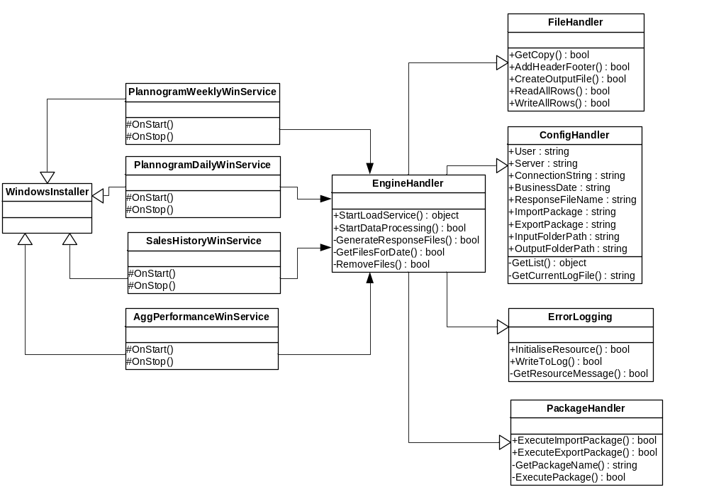

Classes Used

Class | Description
AggPerformanceWinService, PlanogramDailyWinService, PlanogramWeeklyWinService,  SalesHistoryWinService | These windows service class will implement standard interfaces provided by the .net for creating windows services. Each window service upload the file into respective data table.
WindowsInstaller | This class installs the Sales Aggregation Windows Service into local system. It sets the properties of windows service like service name, start type etc.
EngineHandler | This class will be used from the Sales Aggregation Windows Service. This class will actually start the ETL process. This makes call to required functions of FileHandler, ConfigHandler and PackageHandler class. Finally calls the stored procedure to start the request processing.
FileHandler | This is generic class for handling file functions. This has common methods to reading data from file, removing footer from file and adding header , footer to file. These methods would be call from each windows service.
ConfigHandler | This generic class reads the data from app.config file and exposes them through properties of this class. These properties would be accessed by other classes.
ErrorLogging | This is a static class which logs the record in case of any error occurs. It has static method WriteToErrorLog which would be called by other classes for error logging. This Class reads the messages from resource file thus it has private function to initialise the resource.
PackageHandler | This is class to execute the SSIS packages stored on Sql server. It has functions to execute the import and export packages after setting the connection properties. This class gets the package name from the ConfigHandler class’s properties.

Special test conditions to be executed

- If the input file is not available in the specified folder at the specified time.
- More than one input file for a particular type is available
- If one of the fields or rows doesn’t match the expected format.
- Unexpected application or service crash

Local Data Load Component

Design Specifications

- The call to specific load packages from the .NET routine will load the data from the flat files into the respective tables.
- The input path and the file name would be passed to the respective Package for the data load reading from the config file.
- The status of the actions will be logged by the package.

Component Architecture

The Local data load component will be invoked by the data preparation component, once the formatting of the input files is complete. Individual packages have been created for each file upload and they would reside on the SQL server. Calls to execute them will be sent from the .NET routine by providing the source path and the source file name.

The end result of this component would populate the data from the input files into the staging tables of ORMS, IKB and CRDB.

The file format of the input files expected the different external systems are given below.

Request Files from CRDB:

File Type | Column | Description | Positions
Display Hierarchy  (Items for Aggregation) | Record Type | It corresponds to each row in the file.  For File Body it’s value is 01; File Header it’s 00 and File Footer it’s 99 | 1-2
Display Hierarchy  (Items for Aggregation) | ItemNo | Unique Item number | 3-11
Display Hierarchy  (Items for Aggregation) | Sub class Code 1 | Sub class 1 to which the item belongs to. | 12-23
Display Hierarchy  (Items for Aggregation) | Range Event ID | Range Event to which the item belongs to. | 24-31
Display Hierarchy  (Items for Aggregation) | ItemNo In Range Event | Item number that belongs to the range. | 32-39
Display Hierarchy  (Items for Aggregation) | Sub Class Code 2 | Sub class 2 to which the item belongs to. | 40-51
Display Hierarchy  (Items for Aggregation) | Sub Class Description | Description of the Sub class the item belongs to. | 52-75
Aggregation Period | Record Type | It corresponds to each row in the file.  For File Body it’s value is 01; File Header it’s 00 and File Footer it’s 99 | 1-2
Aggregation Period | Range Event ID | Range Event to which the aggregation period belongs to. | 3-10
Aggregation Period | Display Group Code | Display group code for the aggregation period. | 11-13
Aggregation Period | Live Indicator | Event state indicator, Set = 1 if event is live, otherwise set = zero.  A live event is defined as the latest authorised event for a display group with a date <= current business date | 14
Aggregation Period | Event Year/Week | Year and week of the occurrence of event | 15-20
Aggregation Period | Fixed/Rolling Flag | Flag to indicate the period as fixed or rolling. It is ‘F’ or ‘R’. | 21
Aggregation Period | Number of Rolling Weeks | Count of rolling weeks | 22-24
Aggregation Period | Fixed Start Year/Week | Start year/week for fixed period | 25-30
Aggregation Period | Fixed End Year/Week | End year/week for fixed period | 31-36
Stores for Aggregation | Record Type | It corresponds to each row in the file.  For File Body it’s value is 01; File Header it’s 00 and File Footer it’s 99 | 1-2
Stores for Aggregation | Range Event ID | Range Event to which the aggregation period belongs to. | 3-10
Stores for Aggregation | Display Group Code | Display group code for the aggregation period. | 11-13
Stores for Aggregation | Store Range Cluster ID | Cluster ID for that store range | 14-18
Stores for Aggregation | Region Code | Region Code | 19
Stores for Aggregation | Space Break | It is the indication of space allocated for a Display group in a store.  The space break generally falls under A-Z(26 count). A being the least space allocation and Z being the most space allocation | 20
Stores for Aggregation | Store Number | Unique store number | 21-25

Request File from IKB:

File Type | Column | Description | Positions
Replenishment Data Interface | Record Type | It corresponds to each row in the file.  For File Body it’s value is 01; File Header it’s 00 and File Footer it’s 99 | 1-2
Replenishment Data Interface | DateTime | Date and time | 3-12
Replenishment Data Interface | Store Number | Unique store number | 13-22
Replenishment Data Interface | Planogram ID | Planogram ID associated with the Product ID | 23-42
Replenishment Data Interface | Display group | Display group associated with the Product ID | 43-62
Replenishment Data Interface | Event ID | Event ID associated with the Product ID | 63-82
Replenishment Data Interface | Object live date (planogram or floorplan as appropriate) | Live date associated with the Planogram ID | 83-90
Replenishment Data Interface | Object end date (planogram or floorplan as appropriate) | End date associated with the Planogram ID | 91-98
Replenishment Data Interface | Product ID | Unique Product ID | 99-118
Replenishment Data Interface | Capacity | Info on Capacity | 119-123
Replenishment Data Interface | Number of facings wide | Info on Facings | 124-128
Replenishment Data Interface | Number of labels | Count of Labels | 129-131
Replenishment Data Interface | Promotional indicator (generated by this process) | Promotional Indicator | 132
Replenishment Data Interface | Shelf-ready packaging indicator | Packaging indicator | 133
Replenishment Data Interface | Multi-located indicator | Multi-located indicator | 134

Sales Data from ORMS:

File Type | Column | Description | Positions | Remarks
Sales Data from ORMS | RecordType | Constant – 01 for record row | 1-2 | ‘01’
Sales Data from ORMS | ItemNo | Unique Item number | 3-11 | varchar
Sales Data from ORMS | Tran Date | Transaction Date | 12-19 | In the format ‘yyyymmdd’
Sales Data from ORMS | Location | Store number | 20-24 | Numeric (prefix with zeroes)
Sales Data from ORMS | Loc Type | whether Store or warehouse | 25 | varchar
Sales Data from ORMS | Units | Quantity of sale of the item | 26-37 | Numeric (12,4) eg: 123.456 should be represented as 0000123.4560. If the value is negative say -123.456, then it should be displayed as -000123.4560
Sales Data from ORMS | Total Cost | Total cost price of the item | 38-49 | Numeric (12,4) eg: 123.456 should be represented as 0000123.4560. If the value is negative say -123.456, then it should be displayed as -000123.4560
Sales Data from ORMS | Total Retail | Total selling price of the item | 50-61 | Numeric (12,4) eg: 123.456 should be represented as 0000123.4560. If the value is negative say -123.456, then it should be displayed as -000123.4560
Sales Data from ORMS | Tran Code | Transaction Code | 62-63 | Numeric (prefix with zeroes) i.e. Tran code 2 should be displayed as 02
Sales Data from ORMS | Selling UOM | Selling unit of measure | 64-65 | Varchar – either ‘EA’ or spaces
Sales Data from ORMS | VAT Rate | This field will contain the vat rate at the selling store. This field will only contain a value for records with a TRAN_CODE = 1 | 66-72 | Numeric (7, 3) e.g.: 2.345 should be represented as 012.345.

The transaction type information (TRAN_CODE) indicates whether a product has been sold with VAT or without VAT or gone as waste.
If transaction type is 1, then it indicates that a particular product in the particular store has been sold with VAT. The Total Retail field associated with this transaction indicates the Total Sales.

If transaction type is 2, then it indicates that a particular product in the particular store has been sold without VAT. The Total Retail field associated with this transaction indicates the Total Sales.
If transaction type is 22, then it indicates that a particular product in the particular store has gone as waste (inventory cost).

When TRAN_CODE is 22 (for waste), it means that there is no selling cost (Total Retail) associated with it. So it will hold data only Total Cost field only.
Inventory cost means the cost associated with a product which is not sold and goes as waste.

So the daily sales details from ORMS consist of all the above three transaction types.

The interface S004 and S065 sends all the three transaction type data’s to Sales Aggregation. Though they are logically two interfaces, but they handle both Sales and Waste details into one physical interface.

Class Diagram and Method Description

Class Diagram

Classes Used

The following classes (from diagram given above) would take part in data loading:

Class | Description
EngineHandler | This class will be used from the Sales Aggregation Windows Service. This class will actually start the ETL process. This makes call to required functions of FileHandler, ConfigHandler and PackageHandler class. Finally calls the procedure to start the request processing.
ErrorLogging | This is a static class which logs the record in case of any error occurs. It has static method WriteToErrorLog which would be called by other classes for error logging. This Class reads the messages from resource file thus it has private function to initialise the resource.
PackageHandler | This is class to execute the SSIS packages stored on Sql server. It has functions to execute the import and export packages after setting the connection properties. This class gets the package name from the ConfigHandler class’s properties.

Special test conditions to be executed

- Load a data file which has already been loaded once.
- Invoke the package by giving a wrong input file path and name in the config file.
- Provide the log file name and log file path while calling the package and check the level of messages logged.
- Data mismatch in the file.

Data Processing Engine

Design Specifications

- This engine should use the business logic defined below to calculate the aggregated sales information for RPAS system and the actual and historic sales data for IKB systems.
- The Stores will zero sales are excluded from calculation for aggregated sales. But negative sales due to returns are included in the business logic.
- Stored procedures would be used to do the calculations and the data would be formatted before populating them into the Response tables.
- The request tables can be cleaned at the end of the Response table loading.

Component Architecture

Specific stored procedures would be launched for the following activities– one to read the data from the CRDB staging tables and populate the CDRB request table. One stored proc would populate the IKB staging table and would further update the IKB base mapping table. One stored procedure would be required to calculate the daily RPAS response data and another to calculate the IKB response data. The stored procedures would read the requests from the RPAS request table and IKB base mapping tables and perform the aggregation logic on the sales data from ORMS, calculate few fields and then populate the final response tables. The stored procedures would be launched from .NET routines at appropriate times depending on what files are being processed.

Weeks with zero sales will be excluded from the calculation. Similarly, calculations of other performance measure which register zero in any week will exclude that week.
No provision is available to produce an individual sales figure for any multi-located product, as sales/shelf is not captured.

Given below is the description of the business logic involved to calculate the various fields in the response file for RPAS and IKB.

RPAS Response files calculations:

For calculating the average sales value, we follow the below logic:
1. For TRAN_CODE = 1 (inclusive of VAT), Total retail will indicate the total selling price inclusive of VAT of the product in that store in that day. Since the VAT_RATE is also known, subtract the vat rate from the total retail to get the total retail excluding of VAT.
E.g. Total Retail (Ex VAT) = Total Selling Price / ((VAT_RATE / 100) + 1)

And the example: VAT_RATE = 17.5% & Total Retail = 150 then
Total Retail (Ex VAT) = 150 / ((17.5/100) + 1) = 127.6595
This new total retail value will be used for calculating the average weekly sales value exclusive of vat for this week for this year and last year.
2. For TRAN_CODE = 2 (exclusive of VAT), then average sales inclusive of VAT will be same as exclusive of VAT.
3. TRAN_CODE = 22 corresponds to sales for waste.
4. Average sales inclusive of VAT for both this year and last year will be just 1 week data calculation. For exclusive of VAT, then it is for entire aggregation period (rolling/fixed).
e.g. for inclusive of VAT this year, you calculate the average sales for the present week, say you are handling sales for 2007/11. For last year, you will be calculating for 2006/11 (52 weeks difference).

Aggregated Performance Data to RPAS | Record Type | From Files S063
Aggregated Performance Data to RPAS | TPNB | TH.ITEM
Aggregated Performance Data to RPAS | Range Event ID | From Files S063
Aggregated Performance Data to RPAS | Store Cluster | TH.LOCATION
Aggregated Performance Data to RPAS | Range Class | It is the indication of space allocated for a Display group in a store.  The space break generally falls under A-Z (26 count). A being the least space allocation and Z being the most space allocation
Aggregated Performance Data to RPAS | Average Weekly Sales Value (inc.VAT) This Year | Sum of sales units inc of VAT of the product / Count of the no. of stores selling the Product for this year
Aggregated Performance Data to RPAS | Average Weekly Sales Value (inc.VAT) Last Year | Sum of sales units inc of VAT of the product / Count of the no. of stores selling the Product for last year
Aggregated Performance Data to RPAS | Average Sales Per Week (ex. VAT) | Sum of sales units of the product for the week / Count of the no. of stores selling the Product for that aggregation period
Aggregated Performance Data to RPAS | Average Singles Per Week | Sum of sale of single units of the product for the week / Count of the no. of stores selling the Product for that aggregation period
Aggregated Performance Data to RPAS | Average Weight Per Week | Sum of sales of Weight of the product for the week / Count of the no. of stores selling the Product for that aggregation period
Aggregated Performance Data to RPAS | Average No Of Stores for Sales | Count of the no. of stores selling the Product in the week / Aggregation period
Aggregated Performance Data to RPAS | Average Waste Value Per Week | Sum of waste units of the product for the week / Count of the no. of stores where the Product has gone waste in the week for that aggregation period
Aggregated Performance Data to RPAS | Average No Of Stores for Waste | Count of the no. of stores wasted the Product in the week / Number of days of the week of product gone waste for that aggregation period
Aggregated Performance Data to RPAS | Average Margin Value Per Week | Total selling price – Total cost price of the product for that aggregation period
Aggregated Performance Data to RPAS | Average No Of Stores for Margin | Count of the no. of stores having margin value for the Product in the week / Aggregation period
Aggregated Performance Data to RPAS | Launch / Promo Flag | This will always be blank space of 3 character width

IKB Response files calculations:

For IKB the rolling 52 weeks historic sales data and weekly actual sales data should be send once a week. The replenishment interface sends the requests from IKB in the form of flat file each day.

The Historic Sales and Actual Sales units and values will be extracted by the Sales Aggregation Engine for each of the 4 levels of aggregation required for all LIVE Planogram. Sales Aggregation Engine generates 4 flat files comprising of actual and historic sales data for four aggregation levels.
- Historic Sales – the average weekly sales volume (units) and value (£), within a rolling 52 week window
- Actual Sales – the average weekly sales volume (units) and value (£) for the previous week

The following aggregation logic is based on the assumption that the Sales Aggregation Engine will hold raw sales data at product/Planogram/store/week level. Any records where sales values or units =0 should be ignored to ensure these averages are not skewed by unusual events (e.g. for some new products, supply chain issues may result in zero sales for a few weeks whilst the product is on live Planogram).

 | Product | Product/Planogram | Planogram | Planogram/Store
Actual Sales (units) | Sum of sales units of the product for the week / Count of the no. of stores selling the Product in the week | Sum of sales units of the product for the week across stores with that Planogram / Count of no. of stores with that Planogram in that week, where the Product has sales | Sum of sales units of all the products in the Planogram for the week / Count of no. of stores with that Planogram in that week, where the Planogram has sales | Sum of sales units of all the products in the Planogram at a particular store for the week
Actual Sales (£) | Sum of sales (£) of the product for the week / Count of the no. of stores selling the Product in the week | Sum of sales (£) of the product for the week across stores with that Planogram / Count of no. of stores with that Planogram in that week, where the Product has sales | Sum of sales (£) of all the products in the Planogram for the week / Count of no. of stores with that Planogram in that week, where the Planogram has sales | Sum of sales (£) of all the products in the Planogram at a particular store for the week
Historic sales (units) | Sum of sales units of the product over 52 weeks / Count of the unique no. of week/store combinations where the Product has sales | Sum of sales units of the product over 52 weeks across stores with that Planogram / Count of no. of store/week combinations where the Product within that Planogram has sales | Sum of sales units of all the products in the Planogram across 52 weeks / Count of no. of store/week combinations with that Planogram, where the Planogram has sales | Sum of sales units of all the products in the Planogram at a particular store over 52 weeks / Count of the number of weeks where the Planogram has sales in the store
Historic sales (£) | Sum of sales (£) of the product over 52 weeks / Count of the unique no. of week/store combinations where the Product has sales | Sum of sales (£) of the product over 52 weeks across stores with that Planogram / Count of no. of store/week combinations where the Product within that Planogram has sales | Sum of sales (£) of all the products in the Planogram across 52 weeks / Count of no. of store/week combinations with that Planogram, where the Planogram has sales | Sum of sales (£) of all the products in the Planogram at a particular store over 52 weeks / Count of the number of weeks where the Planogram has sales in the store

Class Diagram and Method Description

Class Diagram

Class Used

The following classes (from diagram given above) would take part in data processing:

Class | Description
EngineHandler | This class will be used from the Sales Aggregation Windows Service. This class will actually start the ETL process. This makes call to required functions of FileHandler, ConfigHandler and PackageHandler class. Finally calls the procedure to start the request processing.
ErrorLogging | This is a static class which logs the record in case of any error occurs. It has static method WriteToErrorLog which would be called by other classes for error logging. This Class reads the messages from resource file thus it has private function to initialise the resource.

Response Component

Design Specifications

Following design specifications have been defined for the response component:

- This component should handle the writing of the response files in the expected format and place in the specified output file location.
- Once the final response tables for the IKB and the RPAS systems have been loaded, the .NET routine would give a call to specific SSIS packages which will read the data from these specific response tables, format them as per the response file needs and write them into separate flat files.
- The output file location and the file names will be passed to the SSIS packages from the configuration file.
- These files will be worked upon by a function which will add the standard header and footer information to the file.
- The output files would be available in a specific location at the specified time on the Sales Aggregation outbox folder and would be accessible to the Integration Layer.
- These files would then be moved to archive folder on the Sales Aggregation by the Integration Layer indicating that the file is processed.

The file formats of the various files produced for the external systems have been detailed in the above section itself.

Component Architecture

Once the response table population is completed, the .NET routine calls respective SSIS packages which will write the data from the response tables into separate flat files. These flat files will be worked upon by another .NET routine which will add the standard header and footer to each of the files. The files will then be placed in standard output location.
The RPAS response file will be produced each day and the IKB response files will be produced on a weekly basis.

Class Diagram and Method Description

Class Diagram

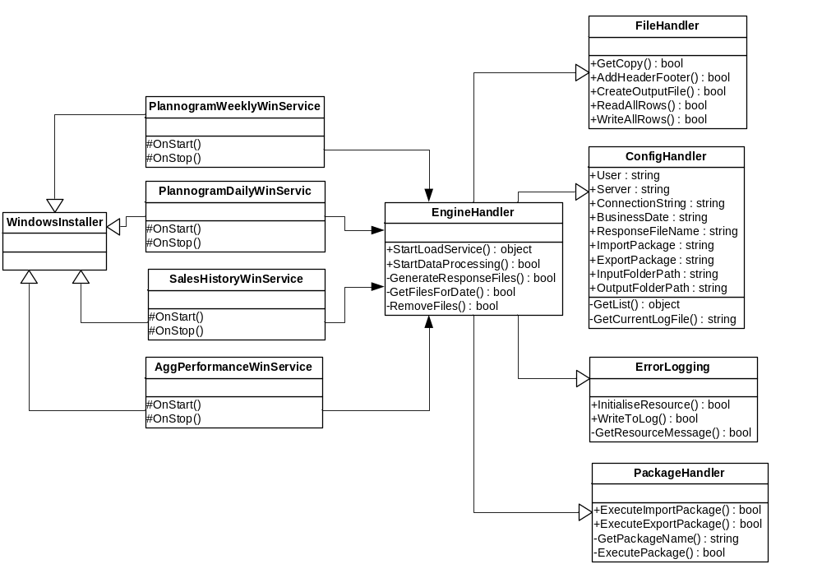

Class Used

The following classes (from diagram given above) would take part in response generation:

Class | Description
FileHandler | This is generic class for handling file functions. This has common methods to reading data from file, removing footer from file and adding header , footer to file. These methods would be call from each windows service.
ConfigHandler | This generic class reads the data from app.config file and exposes them through properties of this class. These properties would be accessed by other classes.
ErrorLogging | This is a static class which logs the record in case of any error occurs. It has static method WriteToErrorLog which would be called by other classes for error logging. This Class reads the messages from resource file thus it has private function to initialise the resource.
PackageHandler | This is class to execute the SSIS packages stored on Sql server. It has functions to execute the import and export packages after setting the connection properties. This class gets the package name from the ConfigHandler class’s properties.

Given below is the layout of the response file for each of the external systems.
It is a daily response file for RPAS and a weekly response files for IKB.

RPAS Response file format:

Sales Aggregation generates a single physical response file containing Sales History, Margin and Waste data. The format of this file is defined below.

Response Type | Column | Description | Position Position
Aggregated Performance Data | Record Type | It corresponds to each row in the file.  For File Body it’s value is 01; File Header it’s 00 and File Footer it’s 99 | 1-2
Aggregated Performance Data | ItemNo | Unique Item number | 3-11
Aggregated Performance Data | Range Event ID | Range Event to which the item belongs to. | 12-19
Aggregated Performance Data | Store Cluster ID | Cluster ID for that store | 20-24
Aggregated Performance Data | Range Class | It is the indication of space allocated for a display group in a store.  The space break generally falls under A-Z(26count). A being the least space allocation and Z being the most space allocation | 25
Aggregated Performance Data | Average Weekly Sales Value (inc.VAT) This Year | Average of the total sale of the item including VAT for this week of this year | 26-37
Aggregated Performance Data | Average Weekly Sales Value (inc.VAT) Last Year | Average of the total sale of the item including VAT for this week of last year | 38-49
Aggregated Performance Data | Average Sales Per Week (ex. VAT) | Average of the total sale of the item excluding VAT for a particular week | 50-61
Aggregated Performance Data | Average Singles Per Week | Average of the total item sold as singles for a particular week | 62-73
Aggregated Performance Data | Average Weight Per Week | Average of the total weight of the item sold for a particular week | 74-85
Aggregated Performance Data | Average No Of Stores for Sales | Average of the total number of stores which have sold that item for a particular week | 86-93
Aggregated Performance Data | Average Waste Value Per Week | Average of the total waste sale of the item for a particular week | 94-105
Aggregated Performance Data | Average No Of Stores for Waste | Average of the total number of stores which have wasted that item for a particular week | 106-113
Aggregated Performance Data | Average Margin Value Per Week | Average of the total retail price minus the total cost for the item for that particular week | 114-125
Aggregated Performance Data | Average No Of Stores for Margin | Average of the total number of stores considered for the margin for the particular week | 126-133
Aggregated Performance Data | Launch / Promo Flag | This will always be blank | 134-136

IKB Response file format:

The Sales Aggregation will be generating 4 different output files for IKB each corresponding to one aggregation level. The format of this file is defined below.

- Aggregation Level - Products

Response Type | Column | Positions
Aggregated Actual and Historic Sales Data | Record Type | 1-2
Aggregated Actual and Historic Sales Data | Product No | 3-11
Aggregated Actual and Historic Sales Data | Actual Sales Volume (value) | 12-23
Aggregated Actual and Historic Sales Data | Actual Sales Volume (Units) | 24-35
Aggregated Actual and Historic Sales Data | Historic Sales Volume (value) | 36-47
Aggregated Actual and Historic Sales Data | Historic Sales Volume (Units) | 48-59

- Aggregation Level – Products / Planogram

Response Type | Column | Positions
Aggregated Actual and Historic Sales Data | Record Type | 1-2
Aggregated Actual and Historic Sales Data | Product No | 3-11
Aggregated Actual and Historic Sales Data | Planogram ID | 12-17
Aggregated Actual and Historic Sales Data | Actual Sales Volume (value) | 18-29
Aggregated Actual and Historic Sales Data | Actual Sales Volume (Units) | 30-41
Aggregated Actual and Historic Sales Data | Historic Sales Volume (value) | 42-53
Aggregated Actual and Historic Sales Data | Historic Sales Volume (Units) | 54-65

- Aggregation Level - Planogram

Response Type | Column | Positions
Aggregated Actual and Historic Sales Data | Record Type | 1-2
Aggregated Actual and Historic Sales Data | Planogram ID | 3-8
Aggregated Actual and Historic Sales Data | Actual Sales Volume (value) | 9-20
Aggregated Actual and Historic Sales Data | Actual Sales Volume (Units) | 21-32
Aggregated Actual and Historic Sales Data | Historic Sales Volume (value) | 33-44
Aggregated Actual and Historic Sales Data | Historic Sales Volume (Units) | 45-56

- Aggregation Level – Planogram / Stores

Response Type | Column | Positions
Aggregated Actual and Historic Sales Data | Record Type | 1-2
Aggregated Actual and Historic Sales Data | Planogram ID | 3-8
Aggregated Actual and Historic Sales Data | Store ID | 9-13
Aggregated Actual and Historic Sales Data | Actual Sales Volume (value) | 14-25
Aggregated Actual and Historic Sales Data | Actual Sales Volume (Units) | 26-37
Aggregated Actual and Historic Sales Data | Historic Sales Volume (value) | 38-49
Aggregated Actual and Historic Sales Data | Historic Sales Volume (Units) | 50-61

Special test conditions to be executed

- Check if the formatting of the fields while writing the output file is as expected.
- Check the time taken for writing a file which has huge volume of response data.

House keeping Component

Design Specifications

Following design specifications have been defined for the house keeping component.

- Daily house keeping activities must be performed on the Sales History database to clean the database for weeks of sales history beyond 2 years.
- Specific stored procedures will be scheduled on the SQL server and they would run automatically each day and perform the clean up action.

Approach

The tables that need to be cleaned up have to be listed prior hand. (As of now, it is the Sales History table alone). Individual Stored procedures would be written to do the clean up action as required and they would be scheduled on the SQL server to run automatically each day. These would be preferably scheduled at times, when the sales aggregation engine is not up and running any aggregation jobs.

- Exception Handling and Logging

The section would cover design and approach for the exception handling and logging mechanism used across multiple tiers in the Sales aggregation Solution.

Logging Mechanism

The proposed design for application logging would use TESCO standard Enterprise Library error management APIs which cater to the following requirements.

- Readability
- It will log all the exceptions occurring during data load, transform and preparation of the response into the Event Viewer
- Provide extensive status information

The error messaged will be displayed in the event viewer. It will contain information as described above for each run of the Sales aggregation engine.
Additionally there can be a log file generated by the SSIS packages for the functionality that it performs. It is optional and can be set, if we need them.

The general exceptions which will be generated in all the methods will be converted to the custom exceptions. The exception details in the message body, along with the time and method name will be displayed in the log file. Where ever possible, the info would be written in easily understandable language.
The unhandled exceptions in the application and application trace [entry and exit from every method] will be logged in the event viewer and trace log file.
The trace log file will be a text file (.txt extension). The file name will be SalesAgg_<ServiceName>_date.txt, where the Service name is the name of the service.

Approach

The exceptions will be logged into an event viewer. When ever a logical step has been completed then information regarding the status of the step would be regularly logged into the log file as described above. No specific Logging levels have been defined at this stage and the log file is expected to contain information as well exception log messages.

The format of the logging file is in the following order:

Date time, Message body.

Date time – shows the time (in YYYYMMDDHI24MMSS format) when the error has occurred or a particular step has been completed.
Message body – will contain info about the step and the status. In case of errors, it will give the details of the method name in which the error occurred and the error or exception details as well.

The data in the log file are comma separated so that this can be easily transferred to ‘.CSV’ file for easy analysis.

File Layout

Headers
RRYYYYMMDDhhmmssYYYYMMDD
RR = Header record, always 00
YYYYMMDDhhmmss = Date/Time file created
YYYYMMDD = Date

Data
RRxxxxxxxxxxxx
RR = Data record, always 01
xxxxxxxxxxxx = Details as in the file layout of Local Data Load and Response component sections above.

Footers
RRCCCCCCCCCC
RR = Footer record, always 99
CCCCCCCCCC = Record count, 9999999999 (Integer 10), this will count data records only. The number will contain leading zeros.

Naming
To ensure that files are not over written they need to be unique, to achieve this, the following suffix to the file name is required:
Business date_Source system_ SystemDescription_System creation date_System creation time.Extention
e.g. 20070330_RPAS_S063_000000_20060330_053345.txt
Business date ccyymmdd
Source system e.g. RPAS, IKB
System Description short text description to identify the content of the file.
System creation date ccyymmdd
System creation time hhmmss
Extension txt

Sample file names for all the interfaces are listed below

CRDB Input files:
20070408_CRDB_ProductParams_20070408_223325.txt
20070408_CRDB_PeriodParams_20070408_221236.txt
20070408_CRDB_StoreParams_20070408_225510.txt

ORMS Input file:
20070408_ORMS_DataExtract_20070408_224650.txt

IKB Input file:
20070408_IKB_ReplenishmentDataExtract_20070408_231010.txt

RPAS Response file:
20070408_RPAS_AggregatedPerformanceData_20070409_031515.txt

IKB Response files:
20070408_IKB_SalesDataForProduct_20070409_031515.txt
20070408_IKB_SalesDataForProductPerPlanogram_20070409_031515.txt
20070408_IKB_SalesDataForPlanogram_20070409_031515.txt
20070408_IKB_SalesDataForPlanogramPerStore_20070409_031515.txt

During normal operation the business date and creation date should be the same, unless the file is created after midnight. However during testing, these dates are likely to be different.

EXTENSION
The input files are expected to be text files and they should contain a .txt extension. Similarly, the output files will also be text files and they will contain a .txt extension.
- Database Design

Design Requirement

- Database should be able to hold sales history for last two years.
- Database should be able to hold the Request data received from CRDB and IKB.
- Daily housekeeping is required for better performance of Sales Aggregation Engine.
- Database should be optimised for performance.

Note: Data received from integration layer will be populated into staging input tables and output data will be first placed in the Output staging tables but later on a job will run to provide the output in a flat file format.

Integration layer is expected to provide data specific to Sales Aggregation Engine to avoid storage of unnecessary data.

Input staging tables

- tbl_Staging_In_Agg_Product_Params
- tbl_Staging_In_Agg_Store_Params
- tbl_Staging_In_Agg_Period_Params
- tbl_Staging_In_Sales_Detail
- tbl_Staging_In_Planogram_Params

Intermediate Tables

- tbl_Config_Param
- tbl_Temp_Agg_PerformanceData

Core Data Tables

- tbl_Sales_Data_Planogram
- tbl_Sales_Planogram_History
- tbl_Agg_Performance_Request
- tbl_Planogram_Params
- tbl_Sales_Data_History

Output staging tables

- tbl_Staging_Out_Product
- tbl_Staging_Out_Planogram_Store
- tbl_Staging_Out_Planogram
- tbl_Staging_Out_Product_Planogram
- tbl_Staging_Out_Agg_PerformanceData

The Database diagram depicting the all the tables are shown below:

db_SalesAggregation

RPAS Request Handling

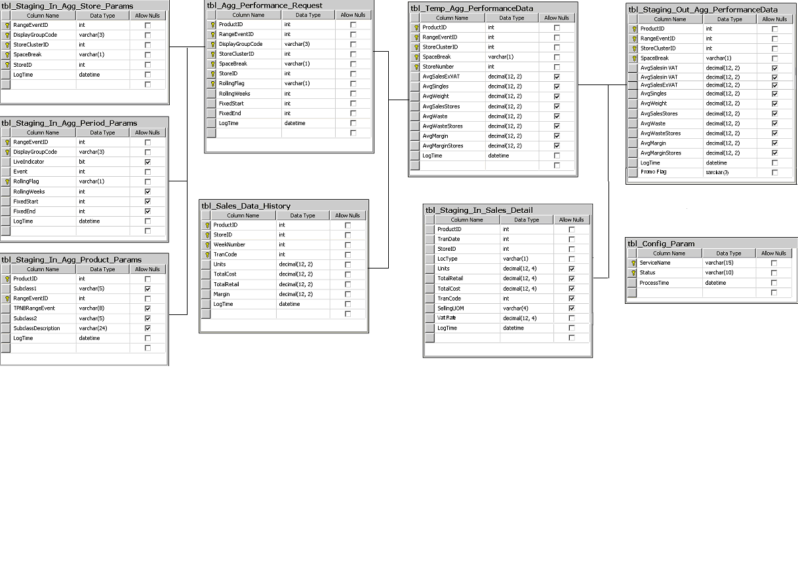

JDA Request Handling

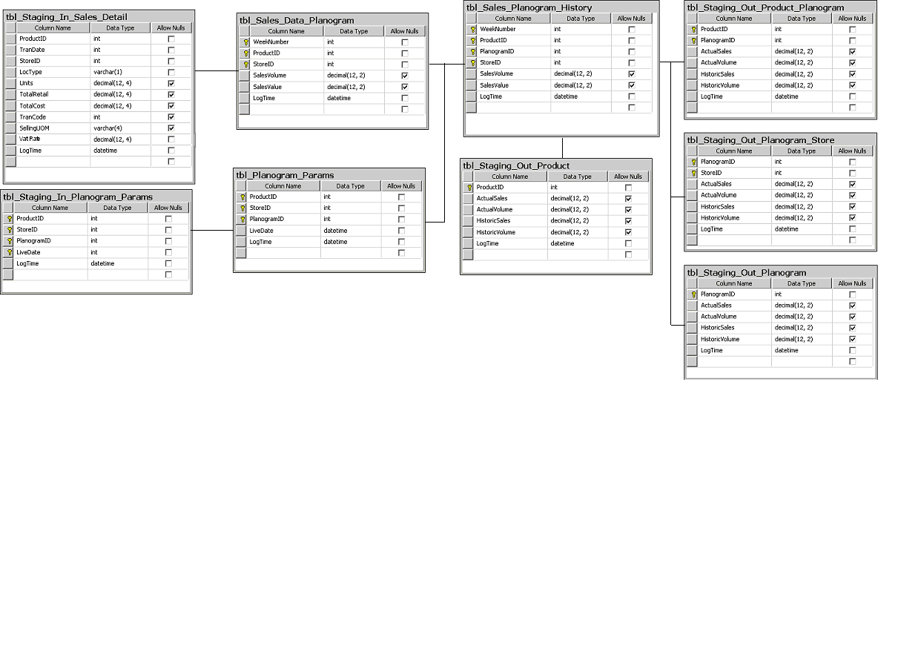

Tables

tbl_Staging_In_Agg_Product_Params

Description | This table is to hold the Range Event Merch Hierarchy interface data coming from CRDB via integration layer.
Primary Key | ProductID, RangeEventID
Indexing Parameters
Database | db_SalesAggregation

S. No | Field Name | Description | Size | Type | Mandatory | Precision | Scale
1. | ProductID | Tesco specific unique product number. | 9 | int | Yes | 10 | 0
2. | Subclass1 | Group of products determined by the way they are displayed eg. Kids Biscuits | 5 | varchar | No
3. | RangeEventID | Number allocated to a ranging event for a display group | 8 | int | Yes | 10 | 0
4. | TPNBRangeEvent |  | 8 | varchar | No
5. | Subclass2 | Group of products determined by the way they are displayed eg. Kids Biscuits | 5 | varchar | No
6. | SubclassDescription | Description of the subclass | 24 | varchar | No
7 | LogTime | DateTime stamp for cleanup purpose | 8 | datetime | Yes

tbl_Staging_In_Agg_Store_Params

Description | This table is to hold the Stores for Aggregation interface data coming from CRDB via integration layer.
Primary Key | RangeEventID,DisplayGroupCode,StoreClusterID,SpaceBreak, StoreID
Indexing Parameters
Database | db_SalesAggregation

S. No | Field Name | Description | Size | Type | Mandatory | Precision | Scale
1. | RangeEventID | Number allocated to a ranging event for a display group |  | int | Yes | 10 | 0
2. | DisplayGroupCode | 3 characters for display group code | 3 | varchar | Yes
3. | StoreClusterID | Group of stores with similar attributes eg. Superstore/Scotland etc. |  | int | Yes | 10 | 0
4. | SpaceBreak | It's the indication of space allocated for a display group in a store. The space break generally falls under A-Z (26 count). | 1 | varchar | Yes
5. | StoreID | unique numeric store identifier |  | int | Yes | 10 | 0
6. | LogTime | DateTime stamp for cleanup purpose | 8 | datetime | Yes

tbl_Staging_In_Agg_Period_Params

Description | This table is to hold the Aggregation Period Parameter interface data coming from CRDB via integration layer.
Primary Key | RangeEventID, DisplayGroupCode, RollingFlag
Indexing Parameters
Database | db_SalesAggregation

S. No | Field Name | Description | Size | Type | Mandatory | Precision | Scale
1. | RangeEventID | Number allocated to a ranging event for a display group |  | int | Yes | 10 | 0
2. | DisplayGroupCode | 3 characters for display group code | 3 | varchar | Yes
3. | LiveIndicator | If the event is live or not | 1 | bit | Yes
4. | Event | Event associated with the event id. |  | int | No | 10 | 0
5. | RollingFlag | Rolling or fixed | 1 | varchar | Yes
6. | RollingWeeks | Number of rolling weeks | 3 | int | No | 10 | 0
7. | FixedStart | Numeric Year/Week | 6 | int | No | 10 | 0
8. | FixedEnd | Numeric Year/Week | 6 | int | No | 10 | 0
9. | LogTime | DateTime stamp for cleanup purpose | 8 | datetime | Yes

tbl_Staging_In_Sales_Detail

Description | This table is to hold the daily sales data coming from ORMS via integration layer.
Composite Primary Key | None
Indexing Parameters
Database | db_SalesAggregation

S. No | Field Name | Description | Size | Type | Mandatory | Precision | Scale
1. | ProductID | Tesco specific unique product number. | 9 | int | Yes | 10 | 0
2. | TranDate | Transaction date time | 8 | int | Yes
3. | StoreID | unique numeric store identifier | 5 | int | Yes | 10 | 0
4. | LocType | Location type for transaction, Store or warehouse | 1 | varchar | Yes
5. | Units | Singles or weight | 12 | decimal | Yes | 12 | 4
6. | TotalRetail | Sale Value | 12 | decimal | Yes | 12 | 4
7. | TotalCost | Cost | 12 | decimal | Yes | 12 | 4
8. | TranCode | Transaction code |  | int | Yes | 10 | 0
9. | SellingUOM | Selling unit of measure | 4 | varchar | Yes | 2
10. | VatRate | Vat rate of the product | 7 | decimal | Yes | 7 | 3
11. | LogTime | DateTime stamp for cleanup purpose | 8 | datetime | Yes

tbl_Staging_In_Planogram_Params

Description | This is staging data table to store the request data for JDA on daily basis.
Composite Primary Key | ProductID, StoreID, PlanogramID, LiveDate
Indexing Parameters
Database | db_SalesAggregation

S. No | Field Name | Description | Size | Type | Mandatory | Precision | Scale
1. | ProductID | Tesco specific unique product number. | 9 | int | Yes | 10 | 0
2. | StoreID | unique numeric store identifier | 5 | int | Yes | 10 | 0
3. | PlanogramID | Unique planogram identifier | 20 | varchar | Yes
4. | LiveDate | Live date of the planogram | 8 | int | Yes
5. | LogTime | DateTime stamp for cleanup purpose | 8 | datetime | Yes

tbl_Config_Param

Description | This temp table captures the completion status of the ORMS and CRDB daily windows services.
Primary Key | ServiceName, Status
Indexing Parameters
Database | db_SalesAggregation

S. No | Field Name | Description | Size | Type | Mandatory | Precision | Scale
1. | ServiceName | Name of the windows Service | 15 | Varchar | Yes
2. | Status | Succes or Failure | 10 | Varchar | Yes
3. | ProcessTime | DateTime stamp for cleanup purpose | 8 | Datetime | Yes

tbl_Temp_Agg_PerformanceData

Description | This temp table holds the RPAS request data at the space break – store number level, before it is aggregated at a space break level in the final response table.
Primary Key | ProductID, RangeEventID, StoreClusterID, SpaceBreak, StoreNumber
Indexing Parameters
Database | db_SalesAggregation

S. No | Field Name | Description |  | Size | Type | Mandatory |  | Precision |  | Scale
1. | ProductID | Tesco specific unique product number. |  | 9 | int | Yes |  | 10 |  | 0
2. | RangeEventID | Number allocated to a ranging event for a display group |  |  | int | Yes |  | 10 |  | 0
3. | StoreClusterID | Group of stores with similar attributes eg. Superstore/Scotland etc. |  |  | int | Yes |  | 10 |  | 0
4. | SpaceBreak | It's the indication of space allocated for a display group in a store. The space break generally falls under A-Z (26 count). |  | 1 | varchar | Yes
5. | StoreNumber | Unique numeric store identifier |  |  | int | Yes |  | 10 |  | 0
6. | AvgSalesIncVATThisYear | Average sales including VAT for this week this year | 12 |  | decimal |  | No |  | 12 |  | 2
7. | AvgSalesIncVATLastYear | Average sales including VAT for this week last year | 12 |  | decimal |  | No |  | 12 |  | 2
8. | AvgSalesExVAT | Average sales excluding VAT for particular product | 12 |  | decimal |  | No |  | 12 |  | 2
9. | AvgSingles | Average singles sale for the particular product | 12 |  | decimal |  | No |  | 12 |  | 2
10. | AvgWeight | Average weight sale for the particular product | 12 |  | decimal |  | No |  | 12 |  | 2
11. | AvgSalesStores | Average stores participating in the sales | 12 |  | decimal |  | No |  | 12 |  | 2
12. | AvgWaste | Average waste for particular product | 12 |  | decimal |  | No |  | 12 |  | 2
13. | AvgWasteStores | Average stores participating in Margin for particular product | 12 |  | decimal |  | No |  | 12 |  | 2
14. | AvgMargin | Average Margin for particular product | 12 |  | decimal |  | No |  | 12 |  | 2
15. | AvgMarginStores | Average stores participating in Margin for particular product | 12 |  | decimal |  | No |  | 12 |  | 2
16. | PromoFlag | Lauch/Promo flag | 3 |  | Varchar
17. | LogTime | DateTime stamp for cleanup purpose | 8 |  | datetime |  | Yes

tbl_Sales_Data_Planogram

Description | This core data table is to store the sales data required for producing JDA output.
Composite Primary Key | WeekNumber, ProductID, StoreID
Indexing Parameters
Database | db_SalesAggregation

S. No | Field Name | Description | Size | Type | Mandatory | Precision | Scale
1. | WeekNumber | Numeric Year/Week | 6 | int | Yes | 10 | 0
2. | ProductID | Tesco specific unique product number. | 9 | int | Yes | 10 | 0
3. | StoreID | unique numeric store identifier |  | int | Yes | 10 | 0
4. | SalesVolume | Weight/singles sold | 12 | decimal | No | 12 | 2
5. | SalesValue | Sale value in currency | 12 | decimal | No | 12 | 2
6. | LogTime | DateTime stamp for cleanup purpose | 8 | datetime | Yes

tbl_Sales_Planogram_History

Description | This is core data table used to store data for producing output for JDA.
Composite Primary Key | WeekNumber, ProductID, PlanogramID , StoreID
Indexing Parameters
Database | db_SalesAggregation

S. No | Field Name | Description | Size | Type | Mandatory | Precision | Scale
1. | WeekNumber | Numeric Year/Week | 6 | int | Yes | 10 | 0
2. | ProductID | Tesco specific unique product number. | 9 | int | Yes | 10 | 0
3. | PlanogramID | Unique planogram identifier | 6 | int | Yes
4. | StoreID | unique numeric store identifier | 5 | int | Yes | 10 | 0
5. | SalesVolume | Weight/singles sold | 12 | decimal | No | 12 | 2
6. | SalesValue | Sale value in currency | 12 | decimal | No | 12 | 2
7. | LogTime | DateTime stamp for cleanup purpose | 8 | datetime | Yes

tbl_Agg_Performance_Request

Description | This table is to capture unique request coming from CRDB. This will be populated after joining the staging input tables.
Primary Key | ProductID, RangeEventID, DisplayGroupCode, StoreClusterID, SpaceBreak, StoreID, RollingFlag
Indexing Parameters
Database | db_SalesAggregation

S. No | Field Name | Description | Size | Type | Mandatory | Precision | Scale
1. | ProductID | Tesco specific unique product number. | 9 | int | Yes | 10 | 0
2. | RangeEventID | Number allocated to a ranging event for a display group |  | int | Yes | 10 | 0
3. | DisplayGroupCode | 3 character for display group code | 3 | varchar | Yes
4. | StoreClusterID | Group of stores with similar attributes eg. Superstore/Scotland etc. |  | int | Yes | 10 | 0
5. | SpaceBreak | It's the indication of space allocated for a display group in a store. The space break generally falls under A-Z (26 count). | 1 | varchar | Yes
6. | StoreID | Unique numeric store identifier |  | int | Yes | 10 | 0
7. | RollingFlag | Rolling or fixed | 1 | varchar | Yes
8. | RollingWeeks | Number of rolling weeks | 3 | int | No | 10 | 0
9. | FixedStart | Numeric Year/Week | 6 | int | No | 10 | 0
10. | FixedEnd | Numeric Year/Week | 6 | int | No | 10 | 0
11. | LogTime | DateTime stamp for cleanup purpose | 8 | datetime | Yes

tbl_Planogram_Params

Description | This is core data table to store the request data for JDA.
Composite Primary Key | ProductID, StoreID, PlanogramID
Indexing Parameters
Database | db_SalesAggregation

S. No | Field Name | Description | Size | Type | Mandatory | Precision | Scale
1. | ProductID | Tesco specific unique product number. | 9 | int | Yes | 10 | 0
2. | StoreID | unique numeric store identifier | 5 | int | Yes | 10 | 0
3. | PlanogramID | Unique planogram identifier | 6 | int | Yes
4. | LogTime | DateTime stamp for cleanup purpose | 8 | datetime | Yes

tbl_Sales_Data_History

Description | This is core data table to store the Sales data history on a week basis.
Composite Primary Key | WeekNumber, ProductID, StoreID, TranCode
Indexing Parameters
Database | db_SalesAggregation

S. No | Field Name | Description | Size | Type | Mandatory | Precision | Scale
1. | ProductID | Tesco specific unique product number. | 9 | int | Yes | 10 | 0
2. | StoreID | unique numeric store identifier | 5 | int | Yes | 10 | 0
3. | WeekNumber | Numeric Year/Week | 6 | int | Yes | 10 | 0
4. | TranCode | Unique planogram identifier | 2 | int | Yes
5. | Units | Sum of units sold in that particular week | 12 | decimal | No | 12 | 2
6. | TotalCost | TotalCost of all the units sold in that week | 12 | decimal | No | 12 | 2
7. | TotalRetail | TotalRetail price of all the units sold in that week | 12 | decimal | No | 12 | 2
8. | Margin | Total margin for all the units sold in that week | 12 | decimal | No | 12 | 2
9. | VatRate | Vat rate of the product | 7 | decimal | Yes | 7 | 3
10. | LogTime | DateTime stamp for cleanup purpose | 8 | datetime | Yes | 9.

tbl_Staging_Out_Product

Description | This is staging output table and stores product aggregation data for JDA
Primary Key | ProductID
Indexing Parameters
Database | db_SalesAggregation

S. No | Field Name | Description | Size | Type | Mandatory | Precision | Scale
1. | ProductID | Tesco specific unique product number. | 9 | int | Yes | 10 | 0
2. | ActualSales | Actual sale in last week | 12 | decimal | No | 12 | 2
3. | ActualVolume | Actual sale volume in last one week | 12 | decimal | No | 12 | 2
4. | HistoricSales | Historic sale in last 52 weeks | 12 | decimal | No | 12 | 2
5. | HistoricVolume | Historic sale volume in last 52 weeks | 12 | decimal | No | 12 | 2
6. | LogTime | DateTime stamp for cleanup purpose | 8 | datetime | Yes

tbl_Staging_Out_Product_Planogram

Description | This is staging output table and stores product, planogram aggregation data for JDA
Composite Primary Key | ProductID, PlanogramID
Indexing Parameters
Database | db_SalesAggregation

S. No | Field Name | Description | Size | Type | Mandatory | Precision | Scale
1. | ProductID | Tesco specific unique product number. | 9 | int | Yes | 10 | 0
2. | PlanogramID | Unique planogram identifier | 6 | int | Yes
3. | ActualSales | Actual sale in last week | 12 | decimal | No | 12 | 2
4. | ActualVolume | Actual sale volume in last one week | 12 | decimal | No | 12 | 2
5. | HistoricSales | Historic sale in last 52 weeks | 12 | decimal | No | 12 | 2
6. | HistoricVolume | Historic sale volume in last 52 weeks | 12 | decimal | No | 12 | 2
7. | LogTime | DateTime stamp for cleanup purpose | 8 | datetime | Yes

tbl_Staging_Out_Planogram_Store

Description | This is staging output table and stores store aggregation data for JDA
Composite Primary Key | PlanogramID, StoreID
Indexing Parameters
Database | db_SalesAggregation

S. No | Field Name | Description | Size | Type | Mandatory | Precision | Scale
1. | PlanogramID | Unique planogram identifier | 6 | int | Yes
2. | StoreID | unique numeric store identifier | 5 | int | Yes | 10 | 0
3. | ActualSales | Actual sale in last week | 12 | decimal | No | 12 | 2
4. | ActualVolume | Actual sale volume in last one week | 12 | decimal | No | 12 | 2
5. | HistoricSales | Historic sale in last 52 weeks | 12 | decimal | No | 12 | 2
6. | HistoricVolume | Historic sale volume in last 52 weeks | 12 | decimal | No | 12 | 2
7. | LogTime | DateTime stamp for cleanup purpose | 8 | datetime | Yes

tbl_Staging_Out_Planogram

Description | This is staging output table and stores planogram aggregation data for JDA
Primary Key | PlanogramID
Indexing Parameters
Database | db_SalesAggregation

S. No | Field Name | Description | Size | Type | Mandatory | Precision | Scale
1. | PlanogramID | Unique planogram identifier | 6 | int | Yes
2. | ActualSales | Actual sale in last week | 12 | decimal | No | 12 | 2
3. | ActualVolume | Actual sale volume in last one week | 12 | decimal | No | 12 | 2
4. | HistoricSales | Historic sale in last 52 weeks | 12 | decimal | No | 12 | 2
5. | HistoricVolume | Historic sale volume in last 52 weeks | 12 | decimal | No | 12 | 2
6. | LogTime | DateTime stamp for cleanup purpose | 8 | datetime | Yes

tbl_Staging_Out_Agg_PerformanceData

Description | This is staging output table and stores daily sales performance aggregation data for RPAS
Primary Key | ProductID, RangeEventID, StoreClusterID, SpaceBreak
Indexing Parameters
Database | db_SalesAggregation

S. No | Field Name | Description | Size | Type | Mandatory | Precision | Scale
1. | ProductID | Tesco specific unique product number. | 9 | int | Yes | 10 | 0
2. | RangeEventID | Number allocated to a ranging event for a display group | 8 | int | Yes | 10 | 0
3. | StoreClusterID | Group of stores with similar attributes eg. Superstore/Scotland etc. | 5 | int | Yes | 10 | 0
4. | SpaceBreak | It's the indication of space allocated for a merchandising group in a store. The space break generally falls under A-Z (26 count). A being the least space allocation and K being the most space allocation. | 1 | varchar | Yes
5. | AvgSalesIncVATThisYear | Average sales including VAT for this week this year | 12 | decimal | No | 12 | 2
6. | AvgSalesIncVATLastYear | Average sales including VAT for this week last year | 12 | decimal | No | 12 | 2
7. | AvgSalesExVAT | Average sales excluding VAT for particular product | 12 | decimal | No | 12 | 2
8. | AvgSingles | Average singles sale for the particular product | 12 | decimal | No | 12 | 2
9. | AvgWeight | Average weight sale for the particular product | 12 | decimal | No | 12 | 2
10. | AvgSalesStores | Average stores participating in the sales | 12 | decimal | No | 12 | 2
11. | AvgWaste | Average waste for particular product | 12 | decimal | No | 12 | 2
12. | AvgWasteStores | Average stores participating in Margin for particular product | 12 | decimal | No | 12 | 2
13. | AvgMargin | Average Margin for particular product | 12 | decimal | No | 12 | 2
14. | AvgMarginStores | Average stores participating in Margin for particular product | 12 | decimal | No | 12 | 2
15. | PromoFlag | Lauch/Promo flag | 3 | Varchar
16. | LogTime | DateTime stamp for cleanup purpose | 8 | datetime | Yes

